**MongoDB -Aggregation Exercises**

**Atlanta Population:**

1. **use db.zipcodes.find() to filter results to only the results where city is ATLANTA and state is GA**.

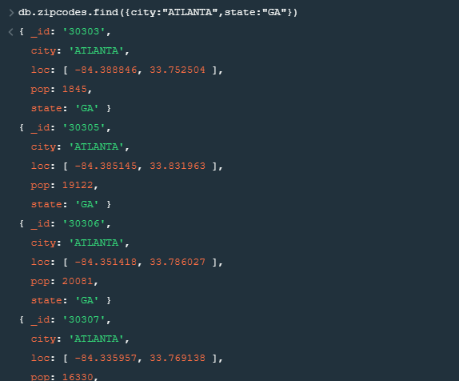

1. **use db.zipcodes.aggregate with $match to do the same as above.**

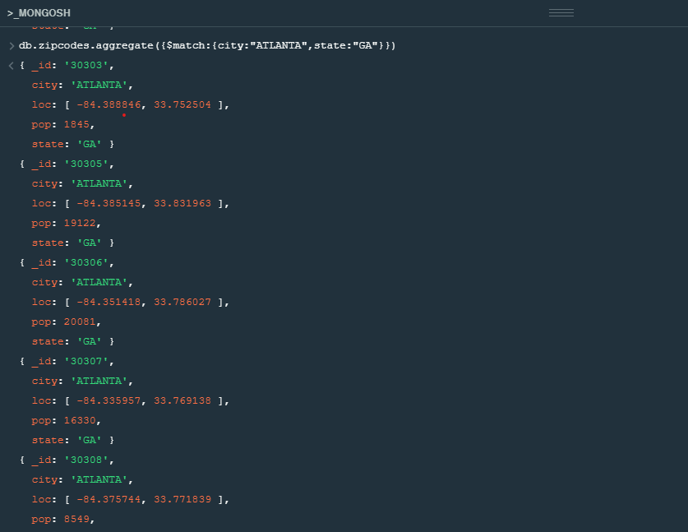

1. **use $group to count the number of zip codes in Atlanta.**



**Populations By state**

1. **use aggregate to calculate the total population for each state.**

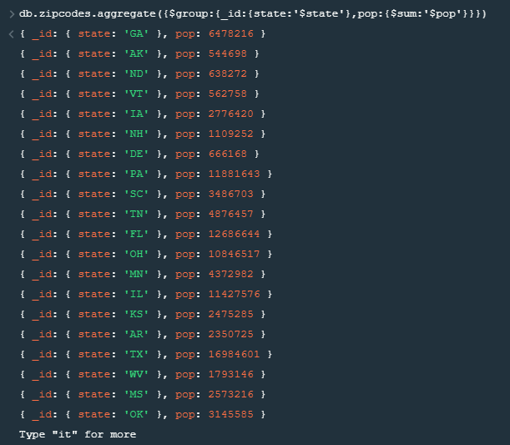

1. **sort the results by population, highest first.**

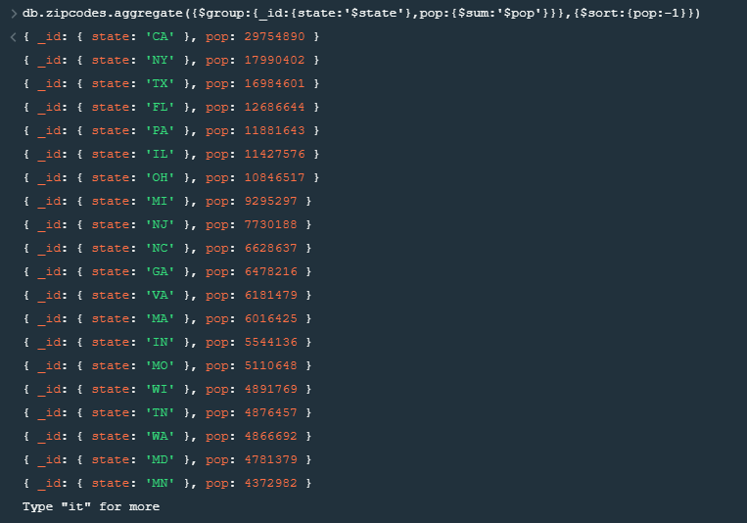

1. **limit the results to just the first 3 results. What are the top 3 states in population?**

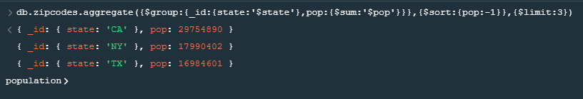

**Populations by City**

1. **use aggregate to calculate the total population for each city (you have to use city/state combination). You can use a combination for the _id of the $group: { city: '$city', state: '$state' }.**

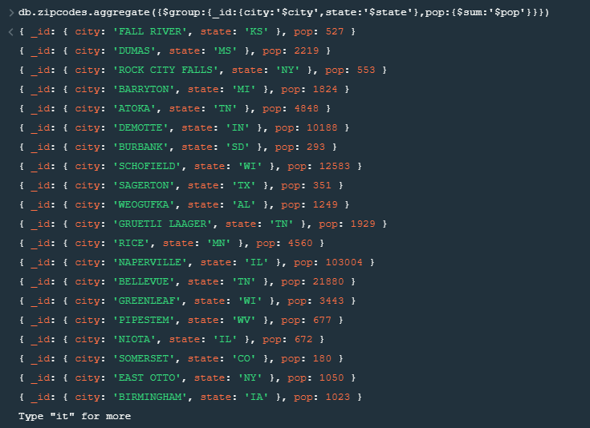

1. **sort the results by population, highest first.**

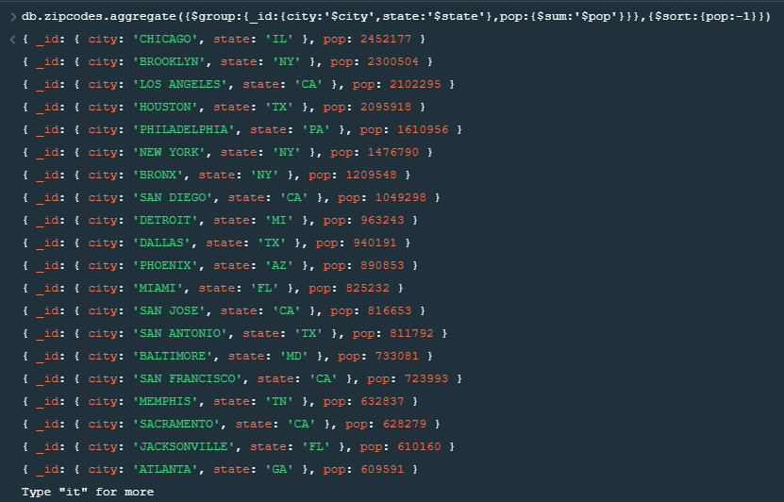

1. **limit the results to just the first 3 results. What are the top 3 cities in population?**

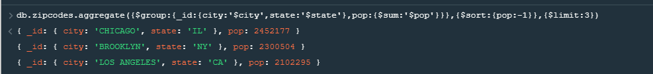

1. **What are the top 3 cities in population in Texas?**

**Bonus**

1. **Write a query to get the average city population for each state.**

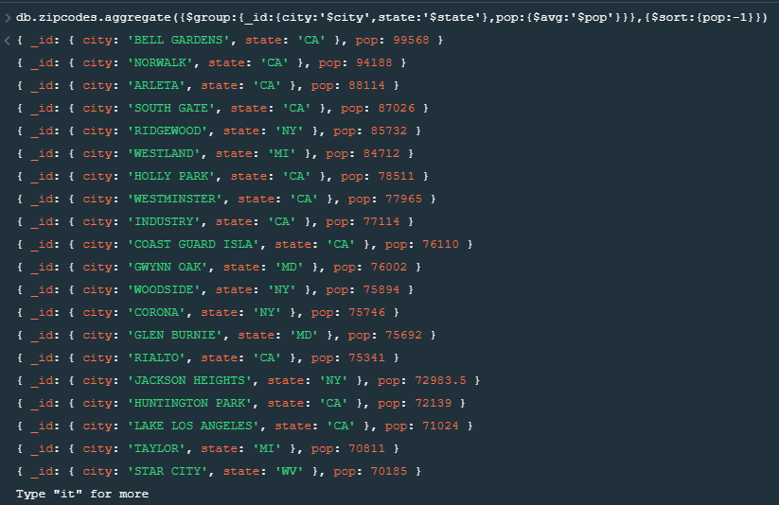

1. **What are the top 3 states in terms of average city population?**

